**(18) Winds**

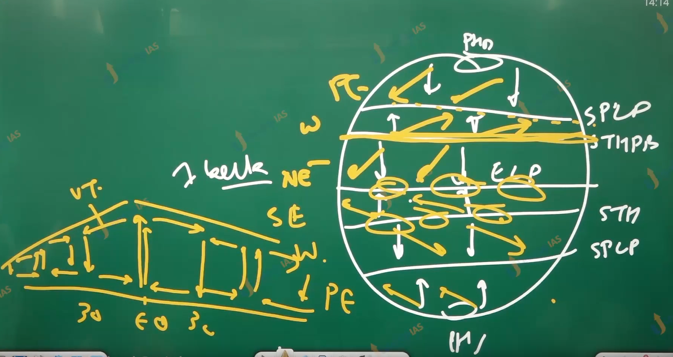

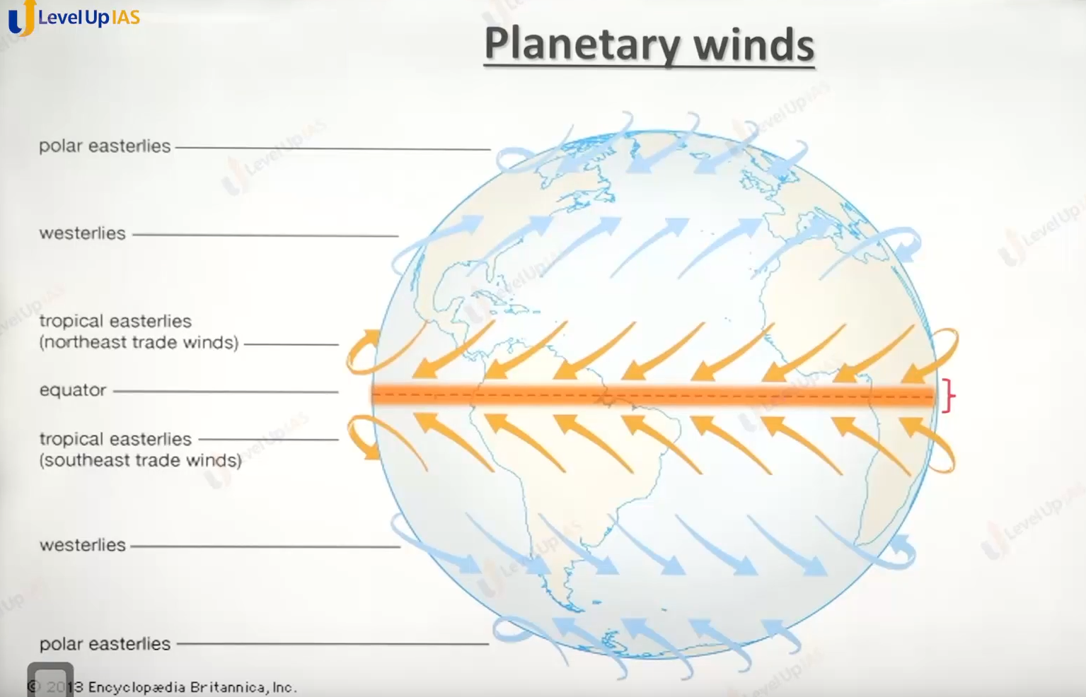

Planetary winds

1. Planetary winds are winds that blows throughout the year they are also known as primary winds
2. They are 3 types
   1. tropical latitudes: northeast trade winds southeast trade winds
   2. Mid latitudes: western leaves
   3. Polar regions: polar easter winds.

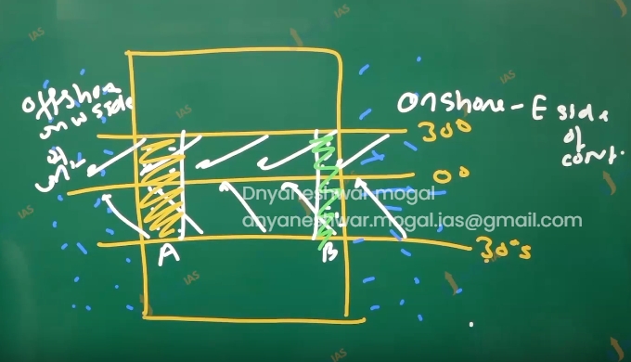

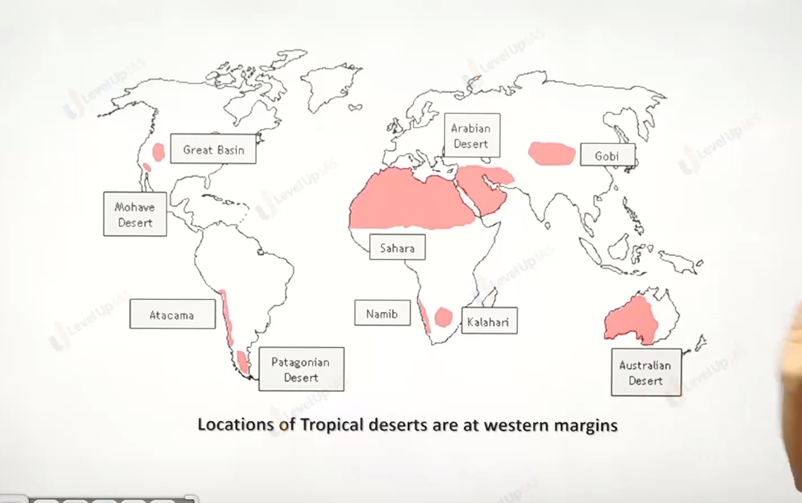

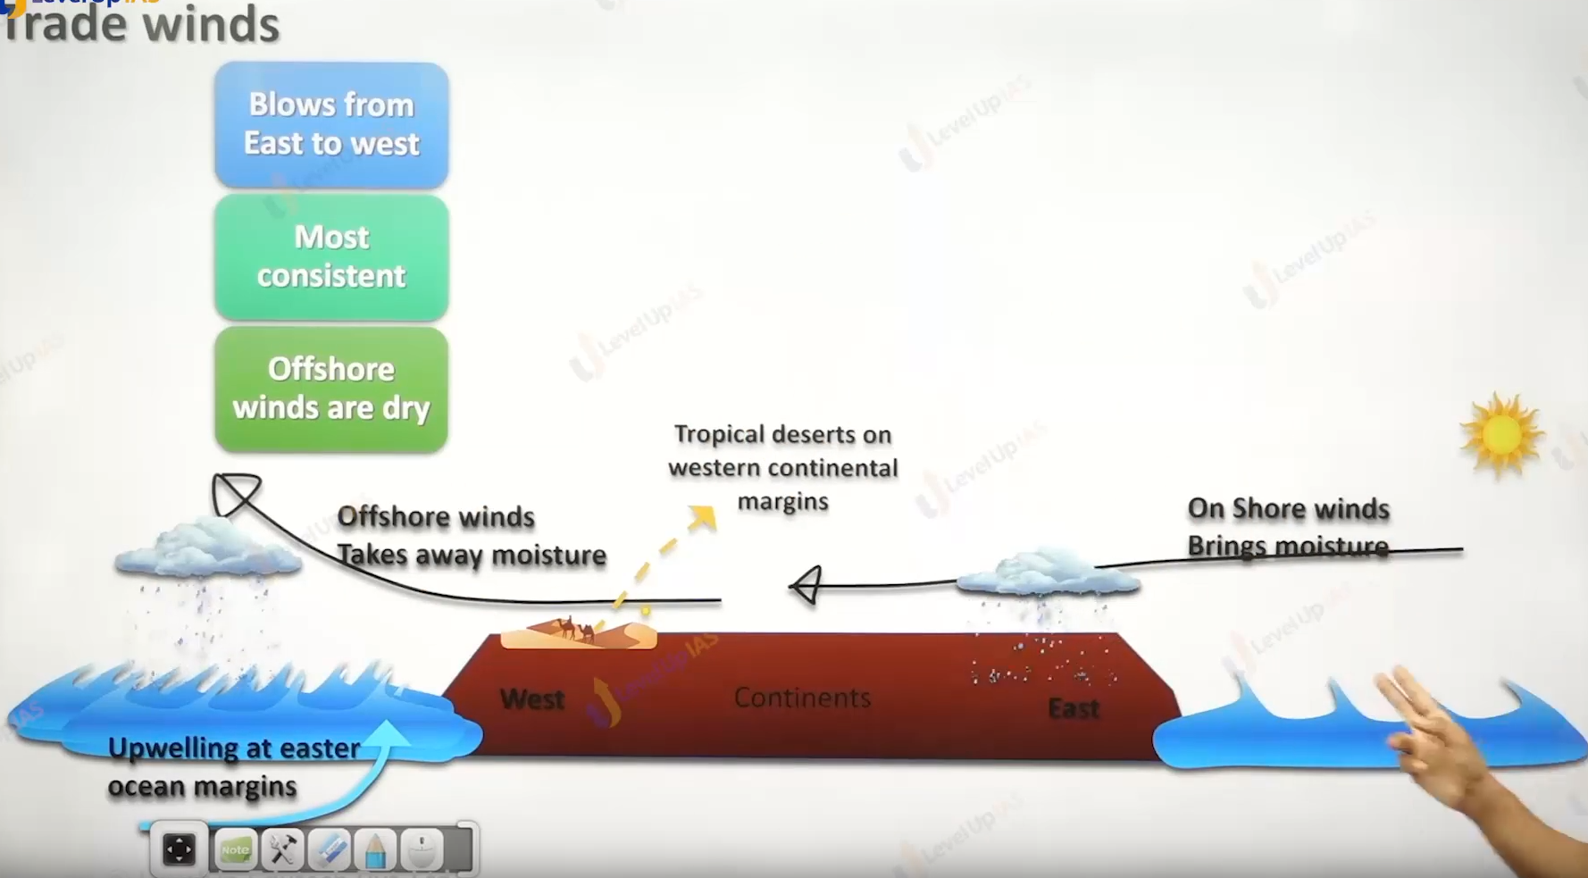

Trade winds

1. Northern hemisphere we have northeast trade winds
2. Southern hemisphere we have southeast trade winds
3. Therefore, they are easterly trade winds and tropical ester lives
4. These winds are onshore on the eastern coast of continental therefore they bring moister on the land. And they are offshore on the western coast therefore they lead to dry conditions.
5. Tropical eastern coast has better climate, whereas the western coast has offshore trade winds desert and they called tropical desert.
6. Offshore trade winds lead to upwelling along the western coast tropical continent. (tropical eastern water. )

Intertropical convergent zone.

ITC ZONE:

1. This zone represents the meeting ground of northeast trade winds and southeast trade winds.
2. There Is seasonal shifting in the ITC ZONE due to apparent shift of sun
3. ITCZ move 5 degrees north or 5 degree south on the water. while shift on the land 20 degrees north to 25 degrees north or south shift is more on the land due to natural of land low specific heat and the relative effect on the pressure.

Doldrum also known as equatorial trough of low pressure.

1. it is belt of low pressure along equator (5degree north and sough )
2. It is belt of calm condition
3. It is a discontinuous belt generally seen in the ocean water and in the colder ocean water.
4. In the belt of doldrum trade winds do not mixed in to one on another and they raise smoothly .

Horse latitude.:

1. Which is steel along 25-to-35-degree latitude in the both the hemisphere
2. It is belt of calm condition due to subsidence of air current
3. In Accent time horses thrown out of ship in order to reduce the weight. So that the ship could shell though calm condition of latitude.

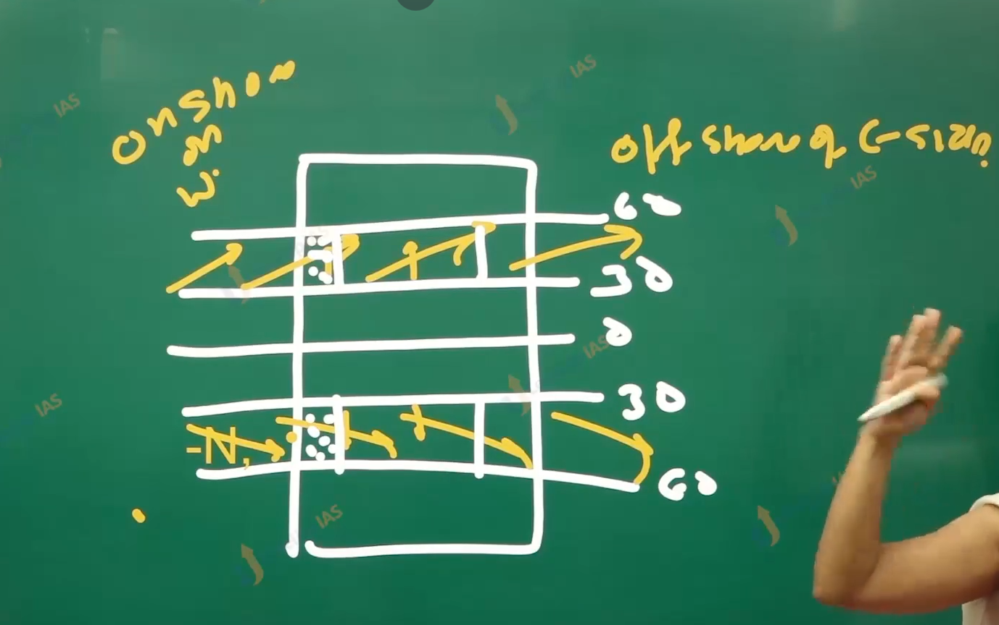

Westernlies:

1. In the northern hemisphere the direction is southwest,
2. In the southern hemisphere the direction is northwest.
3. The Westerlies are onshore on the western side of the mid latitudes continent therefore they bring rainfall. Whereas they are offshore on the eastern side of mid latitudes continent. However, the eastern side of mid latitudes continent is not dry. (Rainfall is because of other factor.
4. There are dry conditions in the mid of continent forming mid latitude continental desert. Gobi Desert, takla mikan desert in China.
5. In the same place in the mid of continent can have temperate grassland in case there is some moister.
6. Westernlies in the southern hemisphere are more powerful and are know as
   1. roaring 40’s.
   2. furious 50’s
   3. shrieking 60’ s
   4. screaming 70’s
7. They are powerful because of the lack of enough land therefore less frictional force.

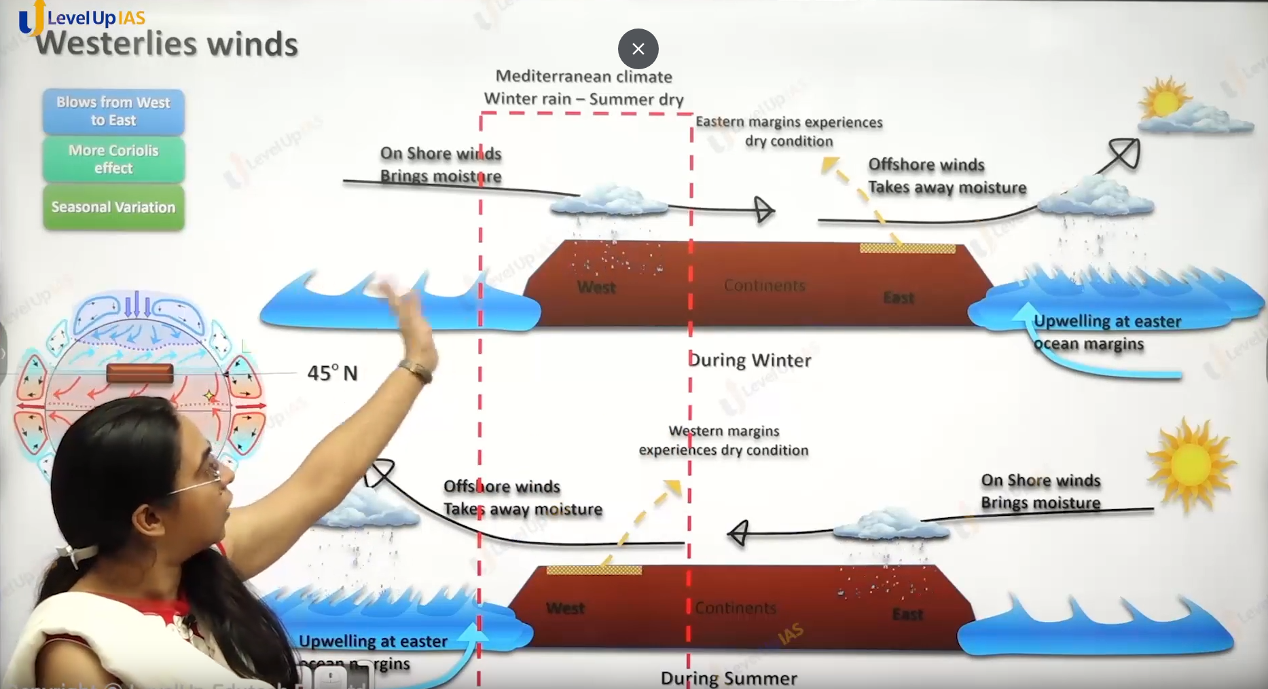

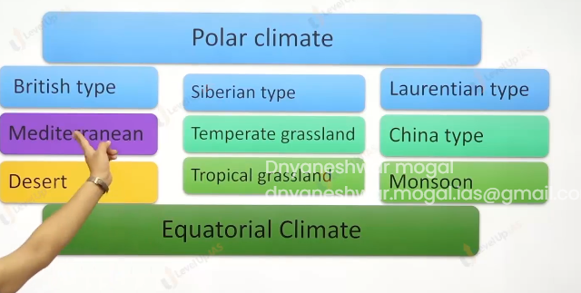

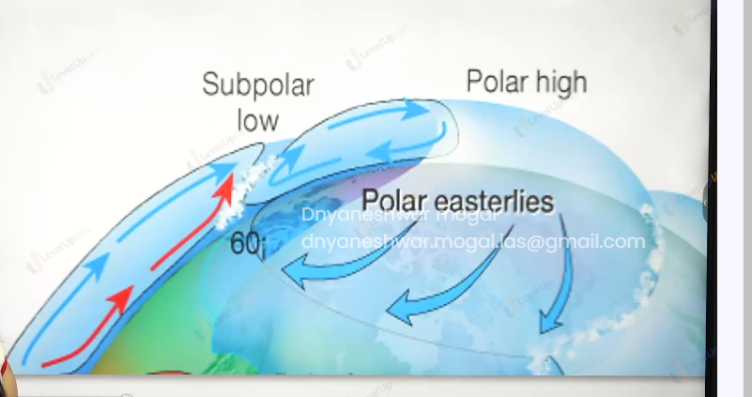

Polar easterlies :

1. They blow along the polar latitude,
2. They are cold and dry they blow from east to west.

Some generic information:

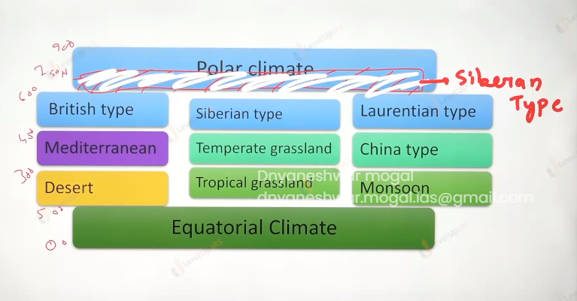

(above picture show the different type of weather on the northern hemisphere.)

Type of desert based on the causal factor.

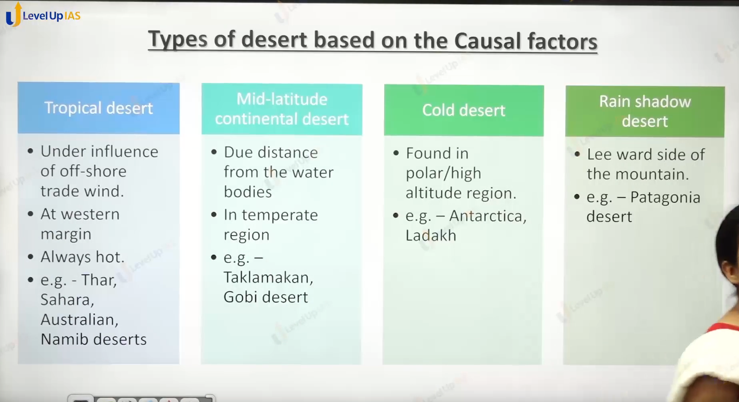

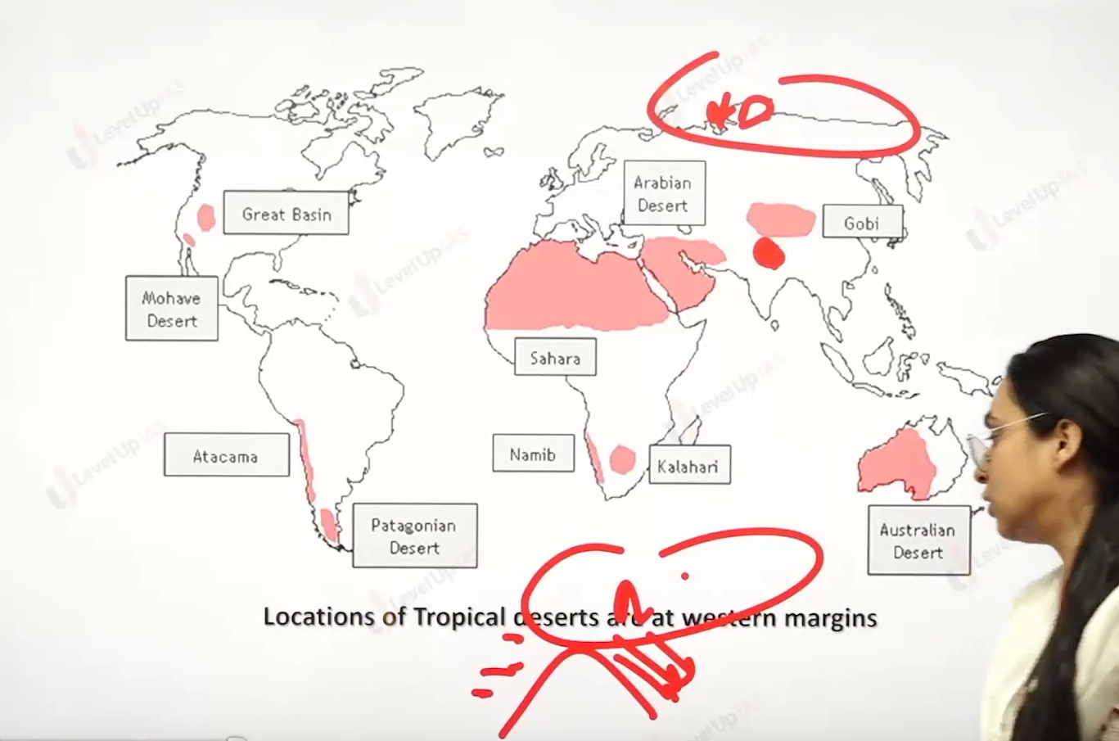

Type of desert

1. Tropical desert: offshore trade wind desert
   1. They are influenced of offshore trade wind. They are found on the western margin of the tropical latitude region
   2. They are hot desert . Ex Mohave desert, coronet desert, chihauahu desert, atcama desert , thar desert, Sahara desert,
   3. Namib desert, great austrilian deert,
2. Mid latitude contienetal desert:
   1. Due to the distance from the water bodies there are dry conditions in the mid of the continent in the middle latitudes.
   2. Ex : gobi desert , Takla makan desert.
3. Rain shadow desert:
   1. They are found on the lever side of mountain ex Patagonia desert on the lever side of candies.
4. Cold desert:
   1. They are found at polar latitude or high-altitude ex. Antarctica, Ladakh.

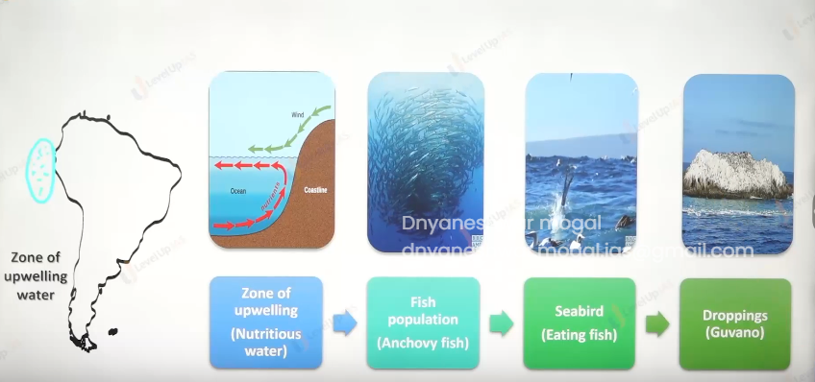

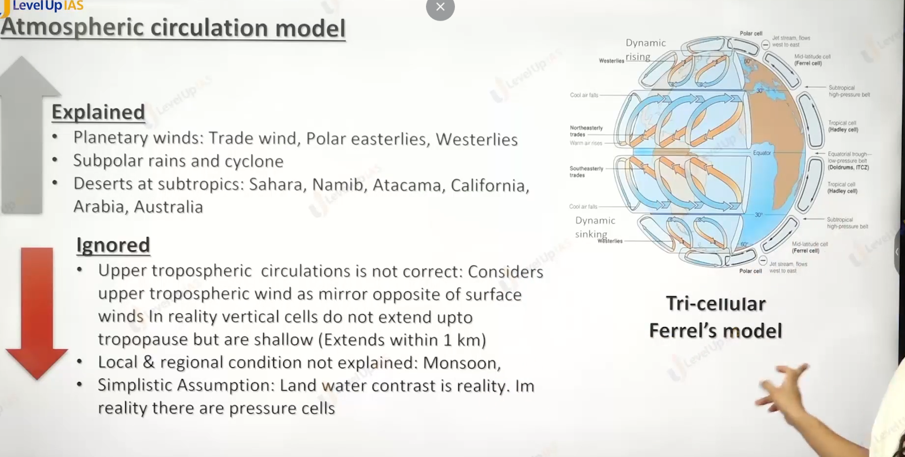

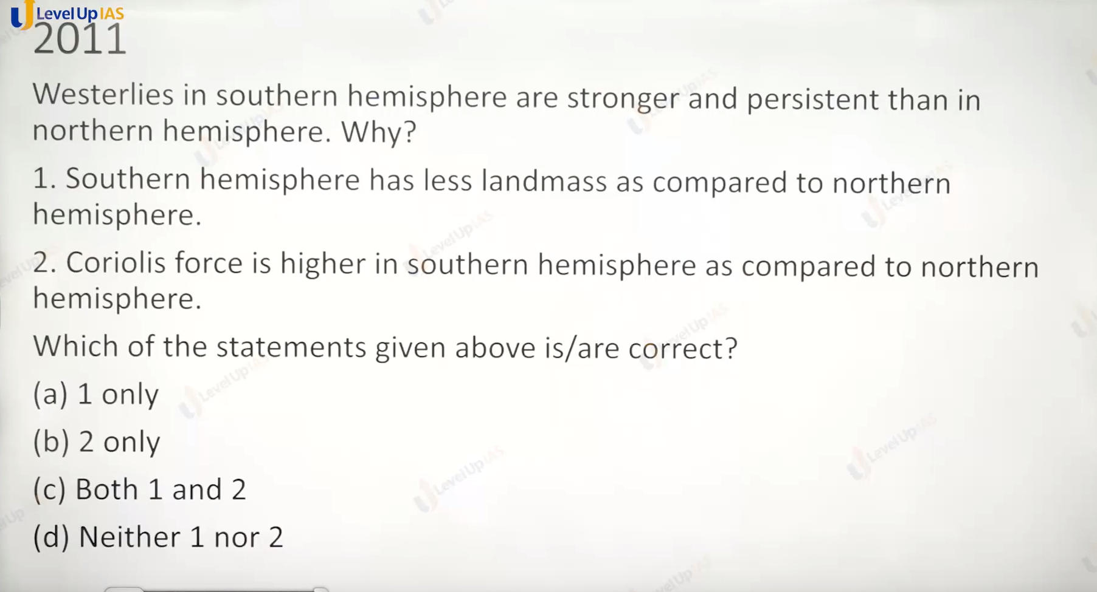

Answer is 1 . There is not relation of hemisphere on the Coriolis force this is due to the earth rotations motions. The effect of Coriolis force might be different due to the friction of land and winds

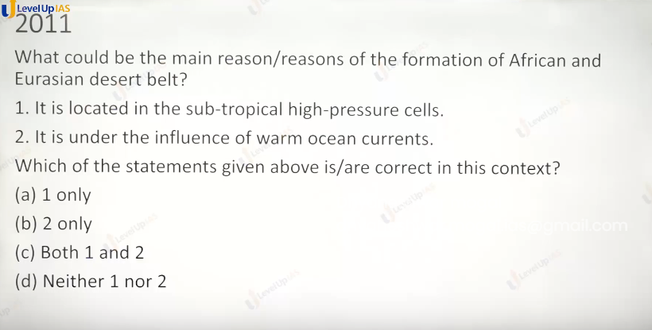

Answer is 1 because the air going to move from there on chance of coming moist air. And for second it Is under influence of cold ocean current.

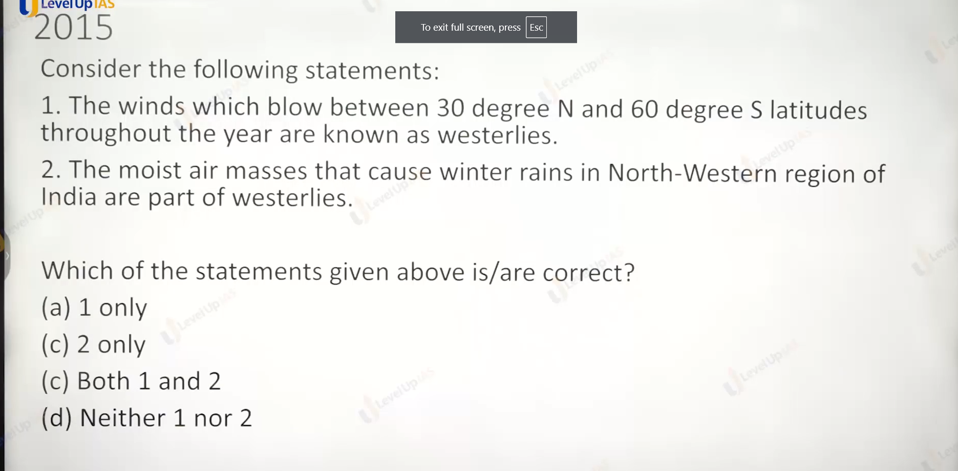

Ans is 2 only , the 1st sentence is wrong. It should be 60 degree north but silly mis take.

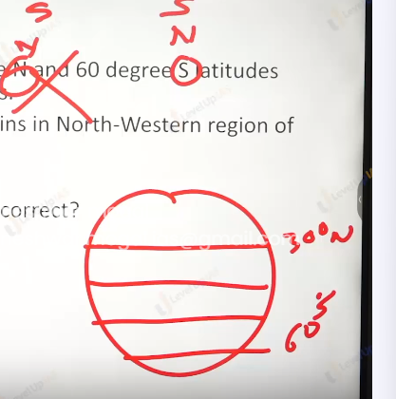

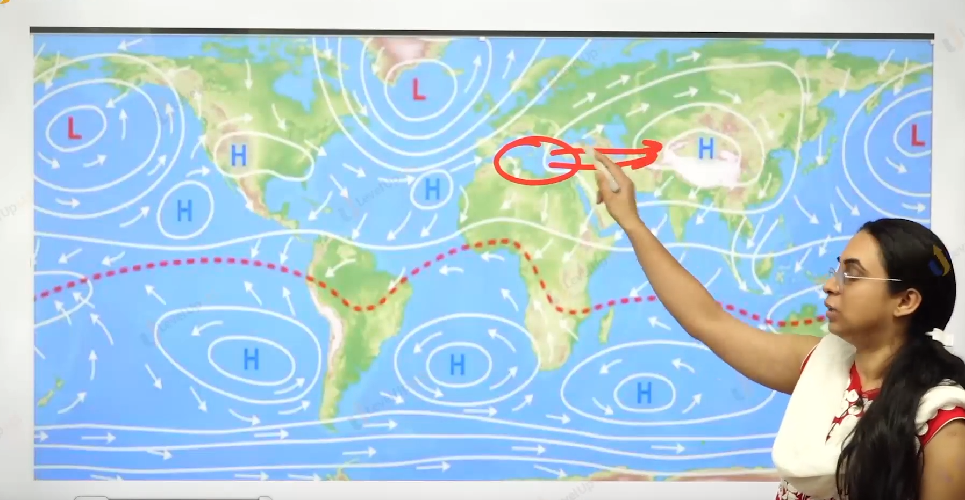

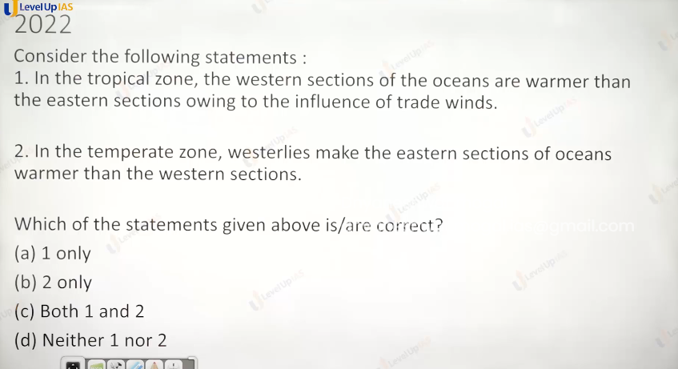

Ans c :

Due to upwelling

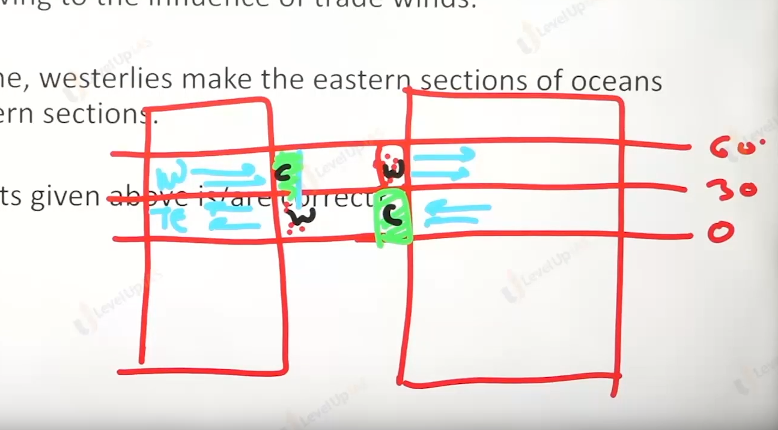

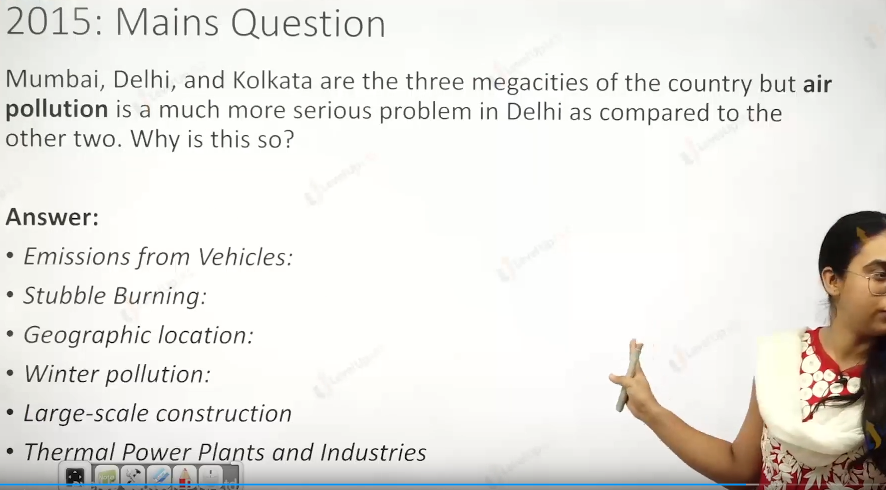

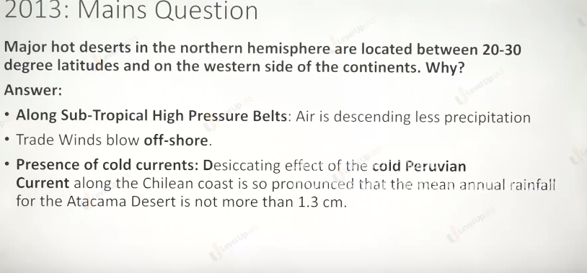

Pressure cells :

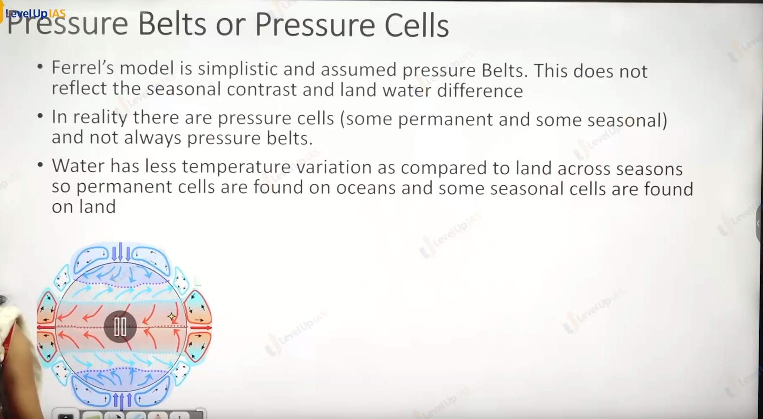

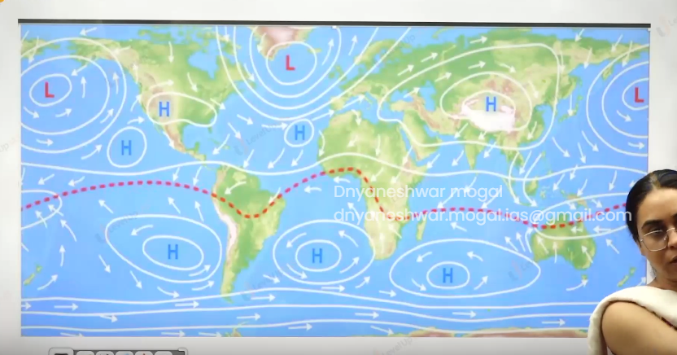

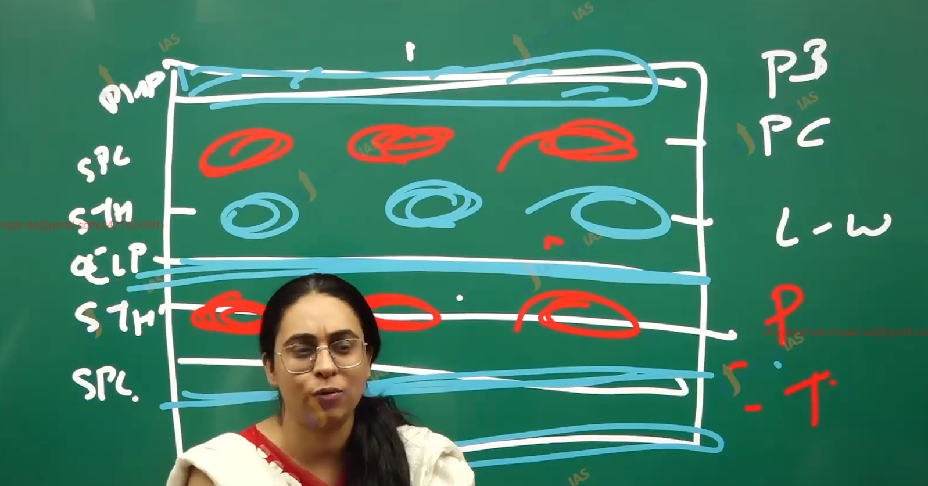

1. Ferell’s model is simplistic and assumed the pressure belts however this was correct based on the assumptions of homogenous earth.
2. But in reality, there are pressure cells (some permanent and some seasonal).
3. Water has less temperature variation as compared to land and therefore permanent cells are found on the oceans and seasonal cells are found on the land.
4. The latitudes same nature across the surface will have the pressure belt. – Ex equatorial low-pressure belt, polar high-pressure belt (north, south), sub-polar low-pressure belt (north and south)
5. The pressure cells are seen in the subpolar low-pressure cell (northern hemisphere.), sub-tropical high-pressure cell. North and south hemisphere.
6. Some important sub-tropical high-pressure cells of southern hemisphere which are permanent are pacific high-pressure cells, Atlantic high-pressure cells, massacring high pressure cells, - found the along the 30 degrees south.